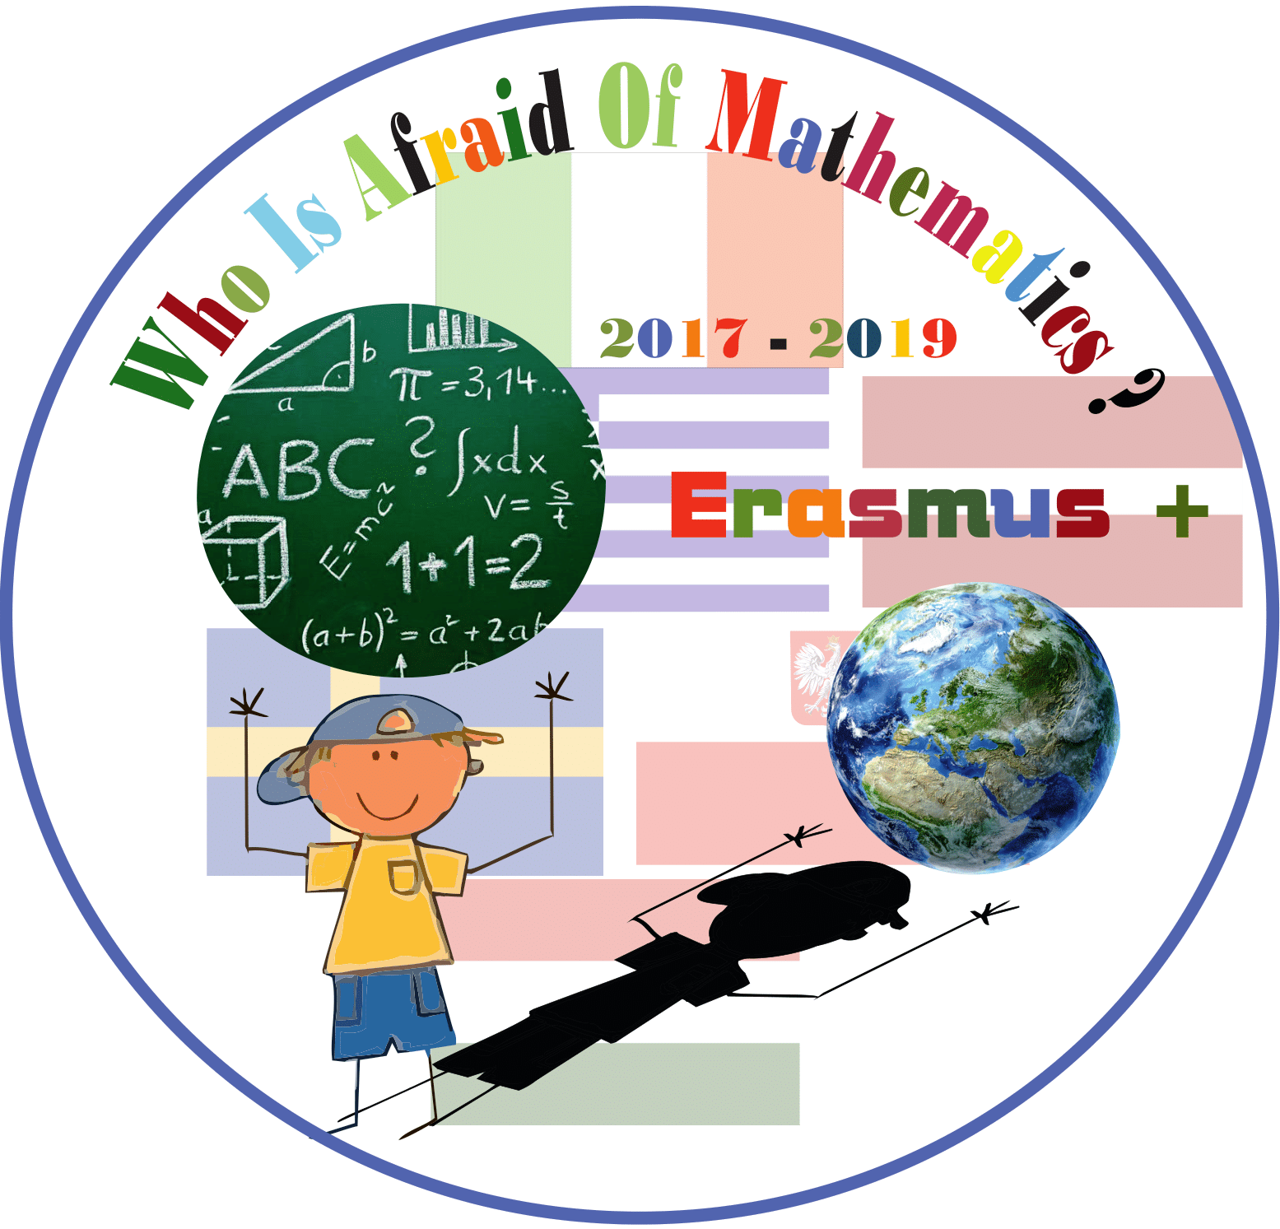

**Category : MATHS IN HISTORY**

**Title of the activity: When MATH, HISTORY and NATURE meet.**

**(Through great oaks to circle, circumference, diameter and radius)**

**Year Group: Grade 4 (9-10 years old)**

**Learning Objectives:**

**-To increase students interest about mathematics in an indirect, understandable way.**

**-Encourage students to get to know the wealth of our native land in history and nowadays.**

**-To present Math topic «Circle, circumference, diameter and radius ».**

**-To provide cross-curricular link.**

**Resources:**

**PowerPoint presentations “Great Oaks- the oldest life form in Latvia” and “Circle, circumference, diameter and radius” in native language.**

**Video**

**How to measure the tree correctly?**

[**http://www.spekozols.lv/**](http://www.spekozols.lv/)

**Wood slices.**

**Compasses, tape measure, board, paper, pencils.**

**nnnnnnnnnnn**

**Success Criteria:**

Students come in touch with Latvian historical value- grand oaks, the oldest life in Latvia.

Pupils are ready to collaborate in different situations and ways.

Students get knowledge through active work and are able to use it practically.

**Differentiation:**

To pay attention: Why are oaks so special in Latvian history and culture?

Are students ready to determinate age of the tree? Can they measure diameter and radius, draw circumference? Is everyone involved in the activities? Is the new knowledge important in their everyday life?

**Lesson Description (including context) :**

This is the lesson when math brings history and nature into the classroom. Students get new knowledge about radius, diameter and circumference through Latvian value- grand oaks. Pupils are encouraged to experiment and to work actively.

**Introduction:**

**Before the main activity students had a trip to the wood where they learnt how to determinate the age of a tree- an outdoor lesson, masterclass.**

**Teacher shows the theoretical part of the PowerPoint presentation national tree- Grand oak, including information:**

**-Oak is symbol of Latvia;**

**-Grand oaks in Latvia;**

**-How to measure the tree correctly;**

**-Interesting facts about oaks;**

**-Oaks in history;**

**-Oaks in Latvian folk songs and tales;**

**Main Lesson:**

1 After the first part of the presentation teacher involves students in a discussion about the value and symbolism of oak in the history and nowadays. Students give their ideas where oaks as symbols are used. Students explore Latvian lats which were used till year 2014. There are pictures of great oaks on 5 and 20 banknotes.

2 Let’s bring the biggest Latvian grand oak into the classroom.

Its circumference is 10.4 m. Students calculate how many 30 cm long paper slips they will need for making 10.4 m circumference. They fasten 35 paper slips together to make as big circumference as the biggest oak has.

3 Children learn how to measure trees correctly.

Using a tape, pupil measure wooden sample in the right height. Then they try to measure it, using everyday things- string, paper, span of the hand and ruler. Later, standing in a tight circle, students make an oak trunk with their bodies and one of them measure it, to make it clear if they can together reach the size of a grand tree.

4 How old are grand oaks?

Children calculate that the oldest oaks are about 900 years old. They 300 years grow, 300 years mature, 300 years perish.

5 Teacher presents theory about radius and diameter.

6 Students measure wooden slices to find out the diameter, radius and circumference. Teacher gives different radii and diameters and asks students to draw circles using compasses. Student practice to draw circles.

**Plenary :**

At the end of the lesson students are ready to draw circle from the given radius and diameter, to calculate circumference. Teacher, asking questions about facts mentioned in the PowerPoint presentation, checks how much information students remember about Latvian value- grand oaks.

